**BOGIE SIMULATION-**

**Stress**

| **Maximum strain** | **0.00010676MPa** |
| --- | --- |
| **Minimum strain** | **3.0136 * 10^-18MPa** |

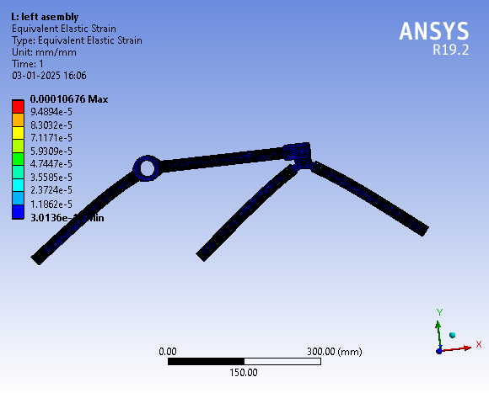

**Total Deformation**

| **Maximum Deformation** | **0.047709mm** |
| --- | --- |
| **Minimum Deformation** | **0mm** |

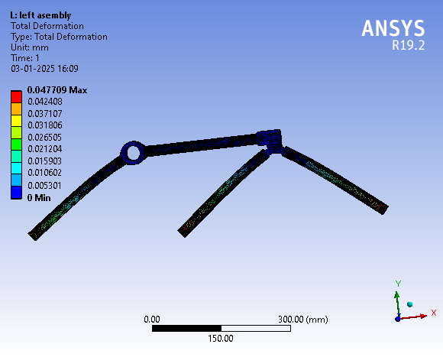

Comment- FOS is 0.177

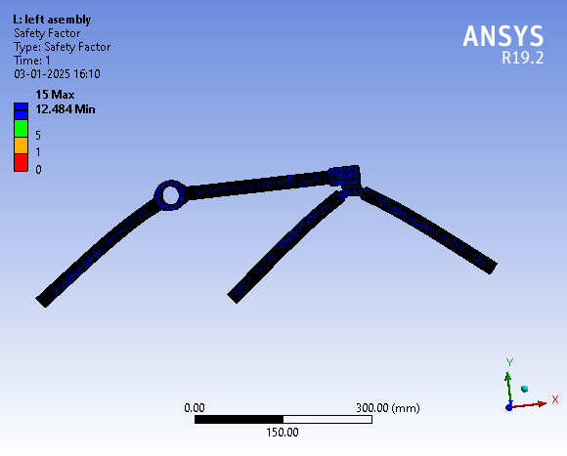

This structure is totally stable and it can hold weight 12.484 time more then the given weight.